**Beginner Project-2**

**To-Do List App (Frontend)**

**Objective:** Build a basic To-Do list web application using HTML, CSS and JavaScript.

**Skills:** Learn how to organize your code into commits and set up a GitHub repository.

**GitHub Concepts**: Regularly commit your progress, create branches for features, and make pull requests.

**Step1**: Initially, Clone the project with the HTML, CSS, and JavaScript File in the Folder

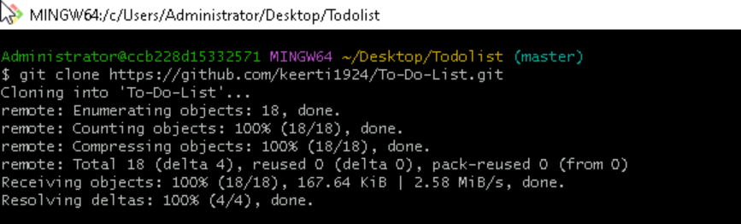

**HTML Code:**

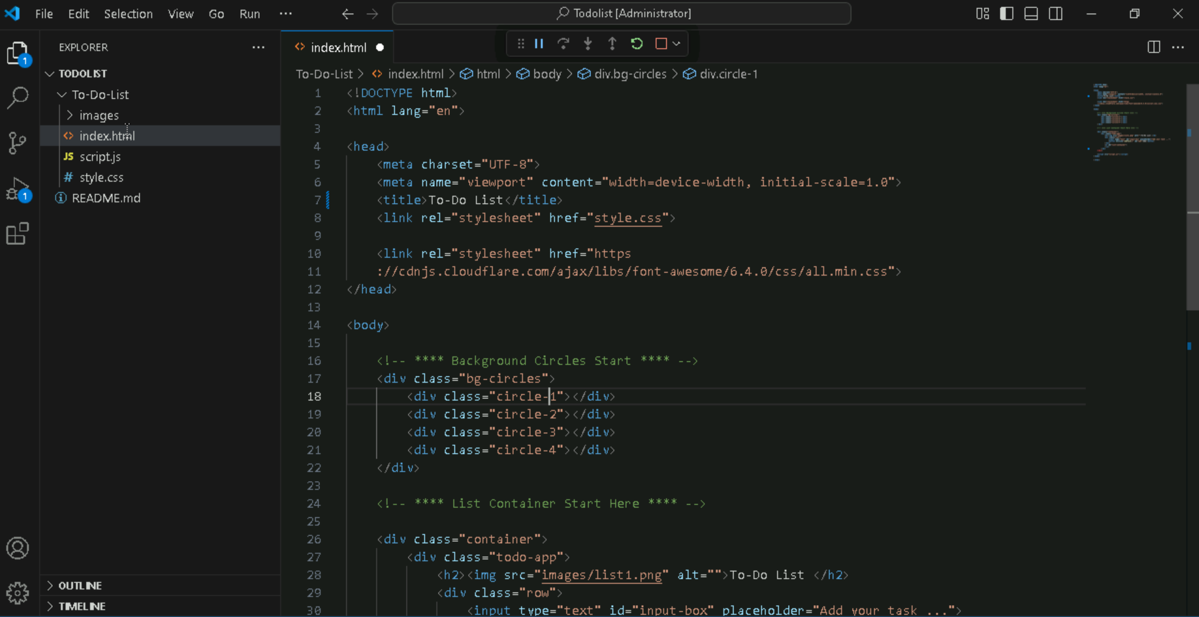

**CSS Code:**

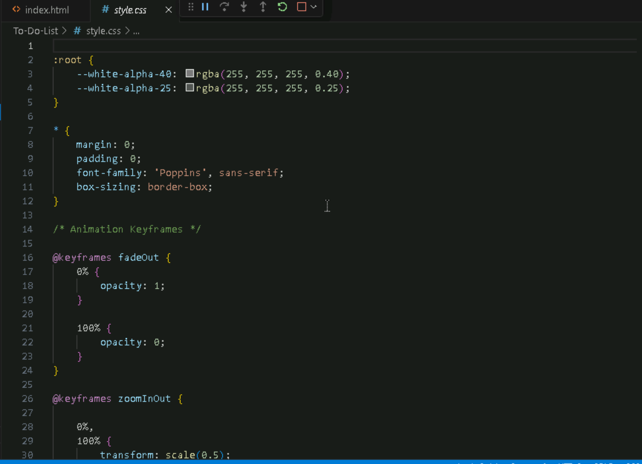

**JavaScript Code:**

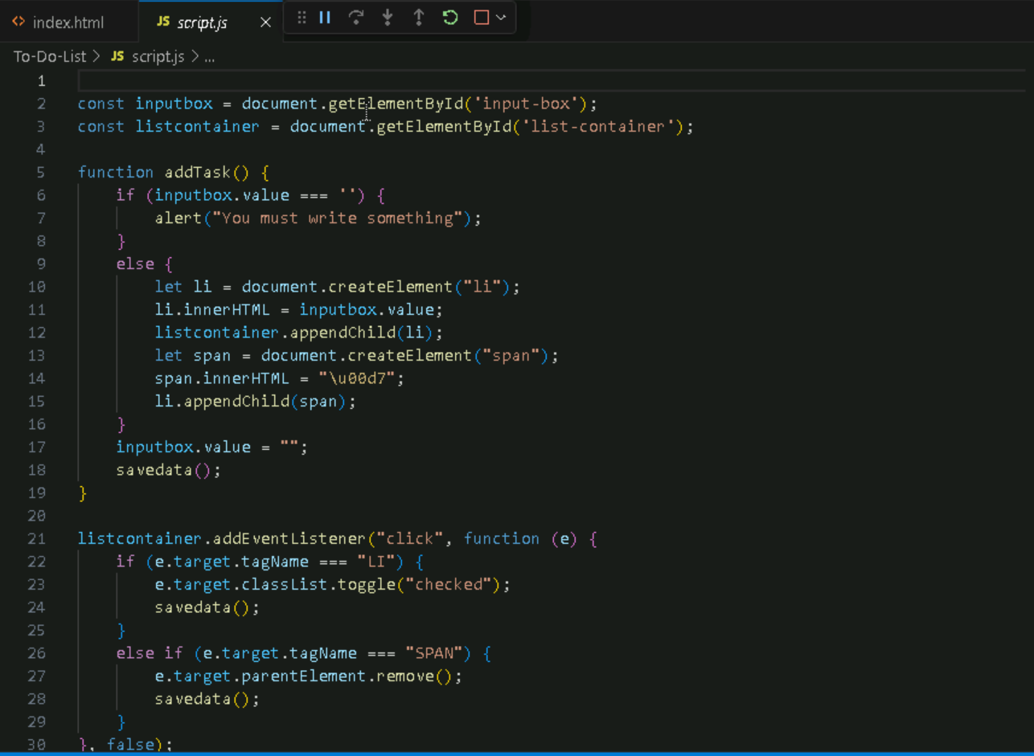

**Step 2:** Initialize the repository using “git init” Command.



**Step 3:** “git remote add origin “git-Link”” command is used in Git to link a local repository to a remote repository.



**Step 4:** The git add . command is used in Git to stage changes in the working directory, preparing them to be included in the next commit.



**Step 5:** This Git command provides information about the current state of the working directory and staging area.

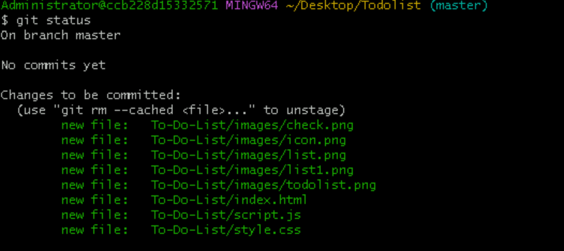

**Step 6:** It fetches and integrates changes from the remote repository’s main branch to local main branch.

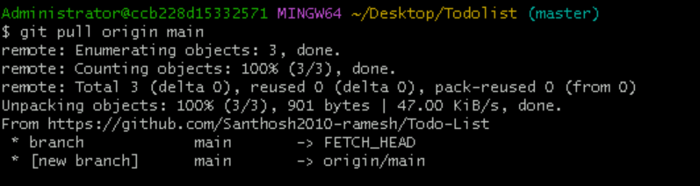

**Step 7:** Now the added files are committed to the repository.

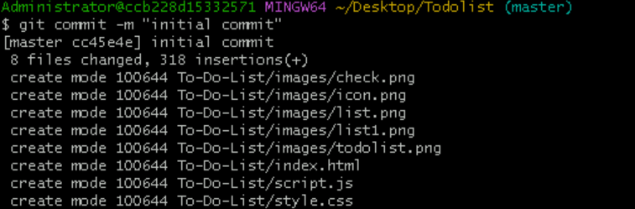

**Step 8:** Pushing the files to the repository using “git push origin HEAD: main”

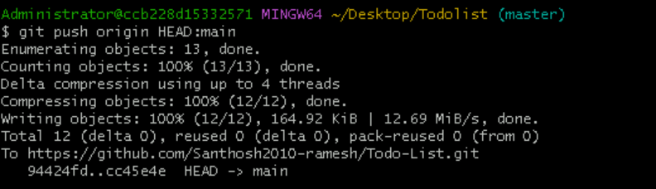

**Step 9**: Now making a minor change in the Title of the => To-Do List as To-Do Lists in the index.html file.

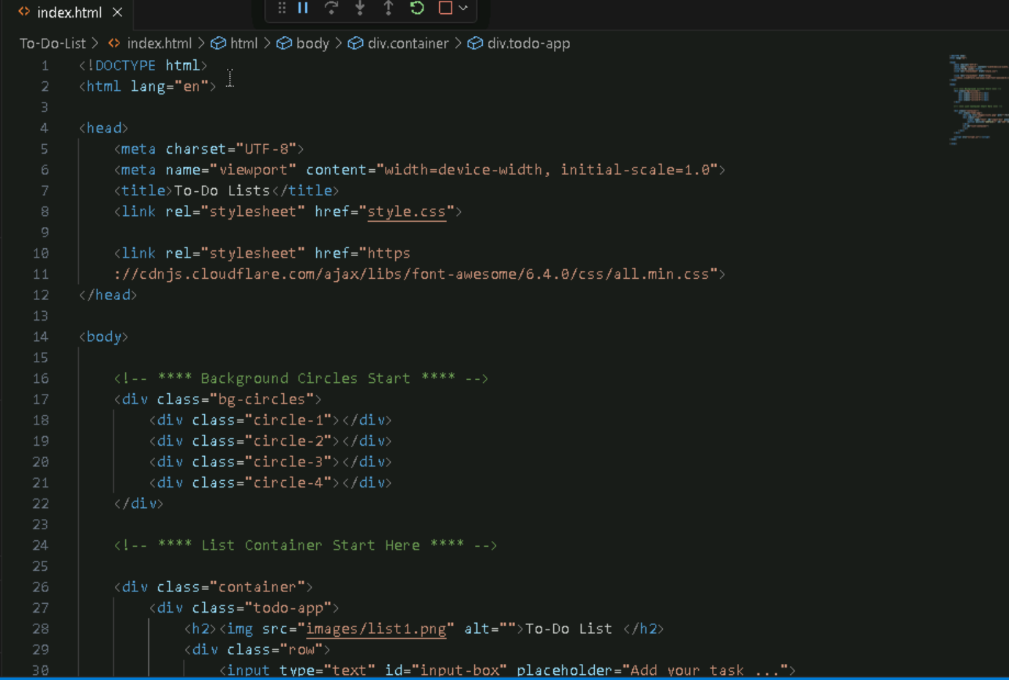

**Step 10:** Now Creating a new branch in the GitHub repository as “new -branches”.

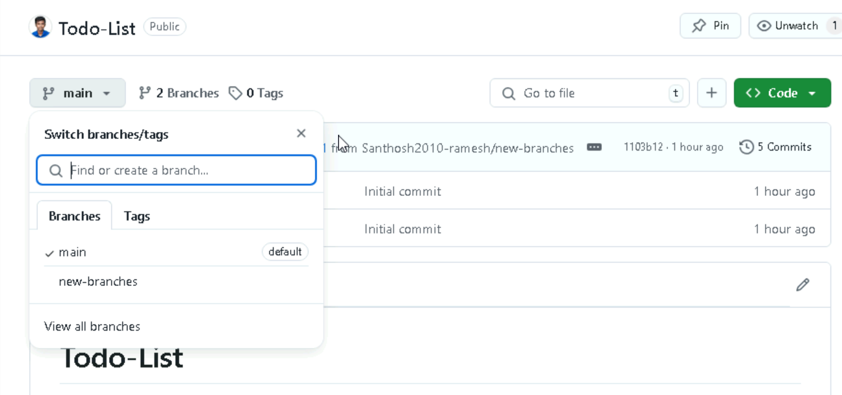

**Step 11:** Now adding all the modified file from the local to the GitHub repository new branch and committing the changes.

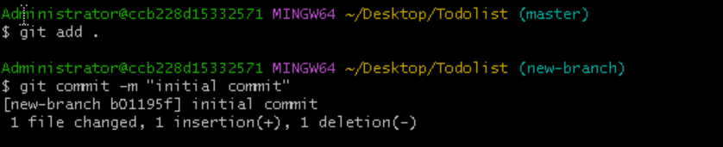

**Step 12:** Now pushing the modified files to the new branch

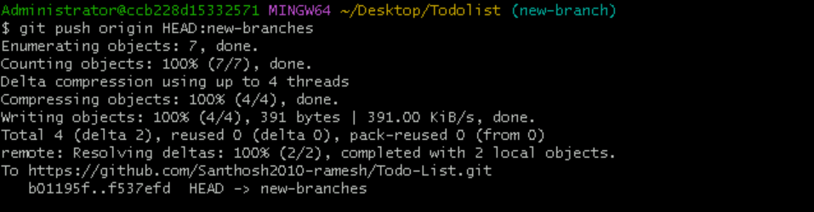

**Step 13:** Comparing and requesting the pull from the new branch to the main branch.

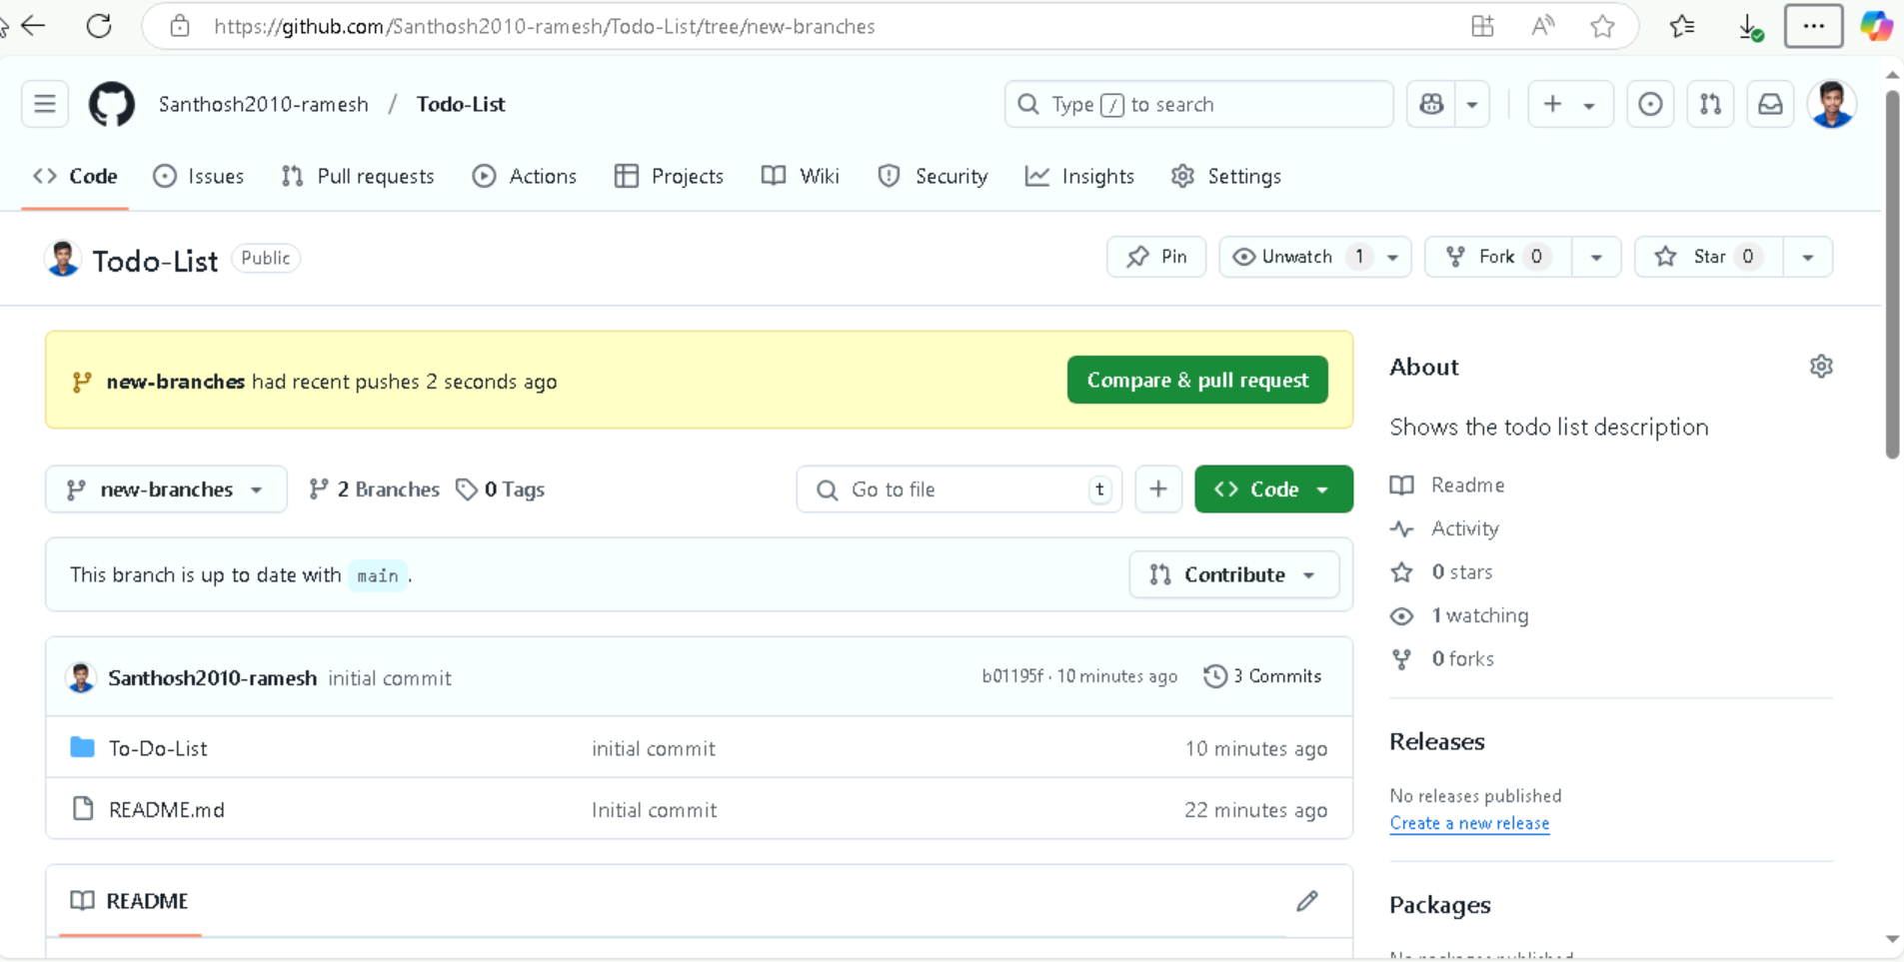

**Step 14**: After the difference is pointed the pull request is created.

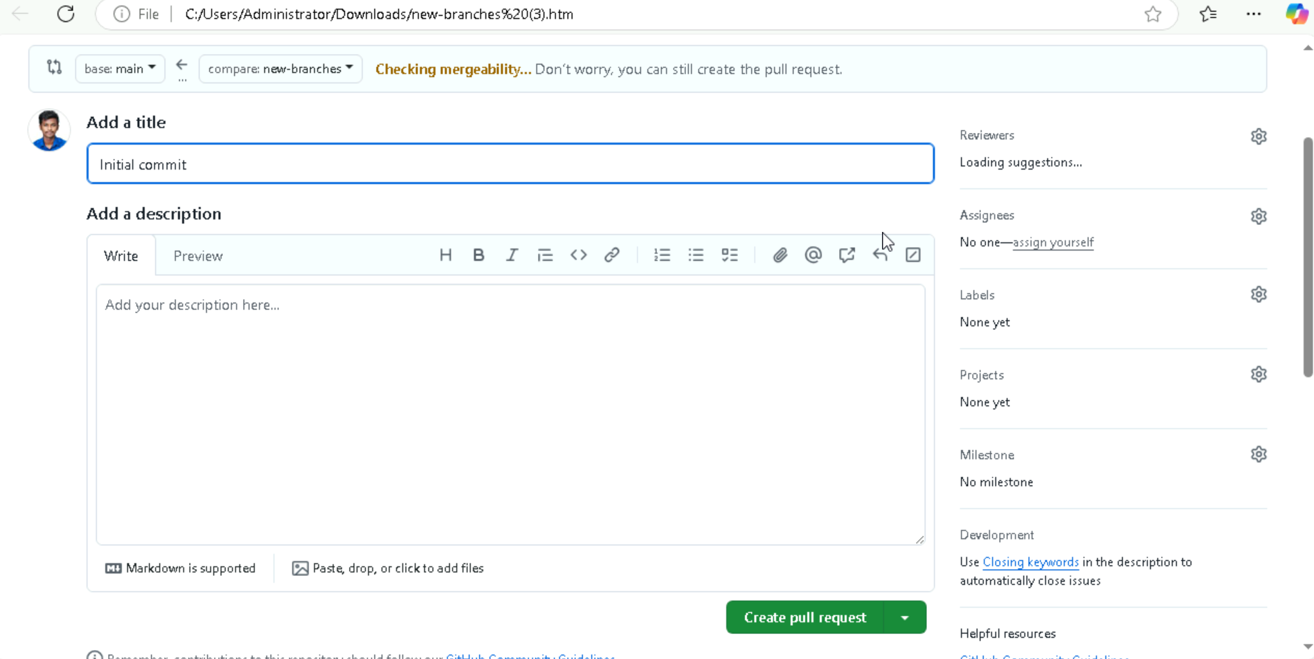

**Step 15:** Now Merging the pull request in GitHub.

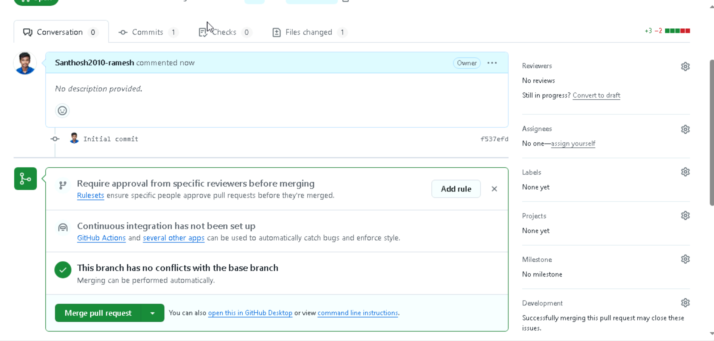

**Step 16:** Submit and confirm the merge request.

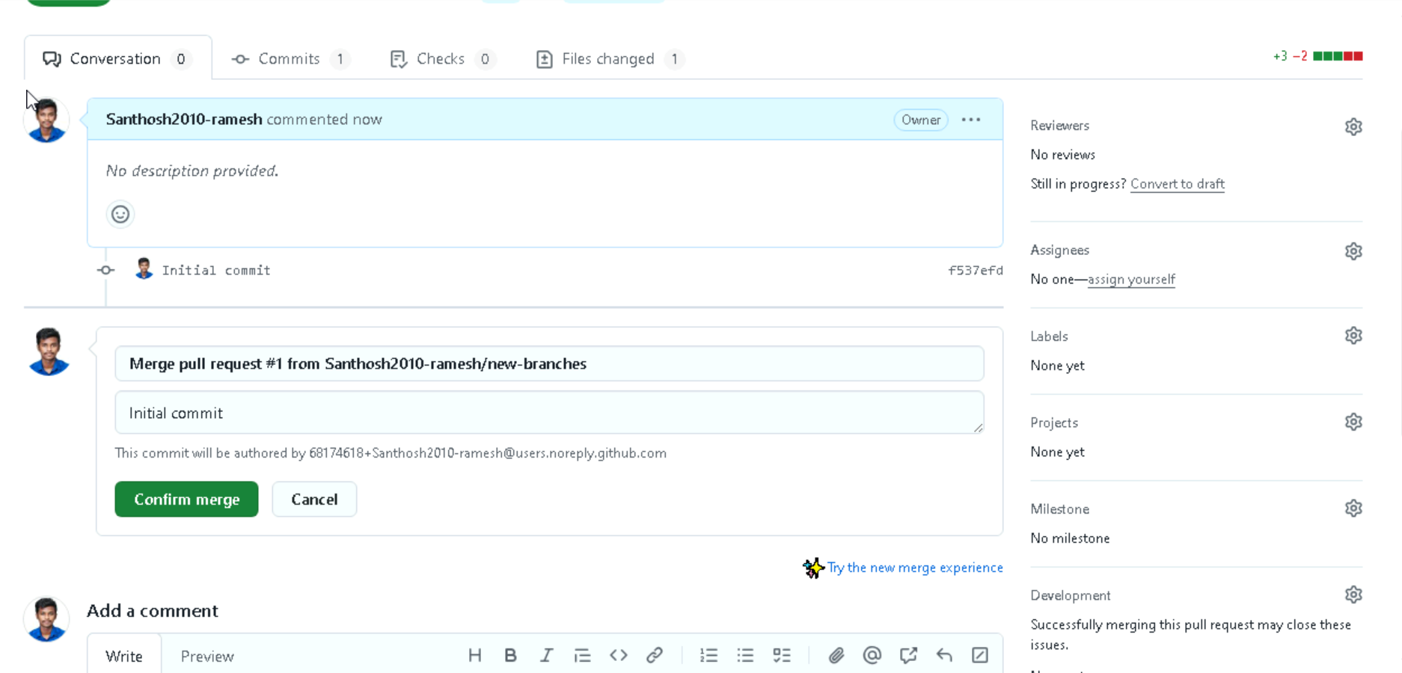

**Step 17:** Pull request is successfully merged and closed.

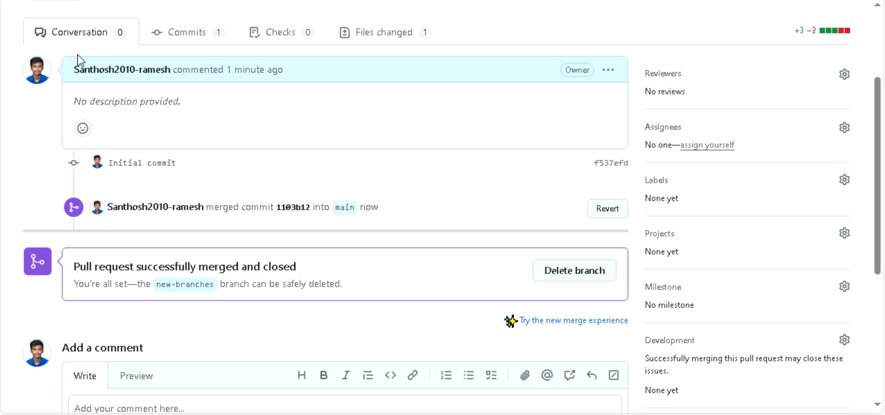

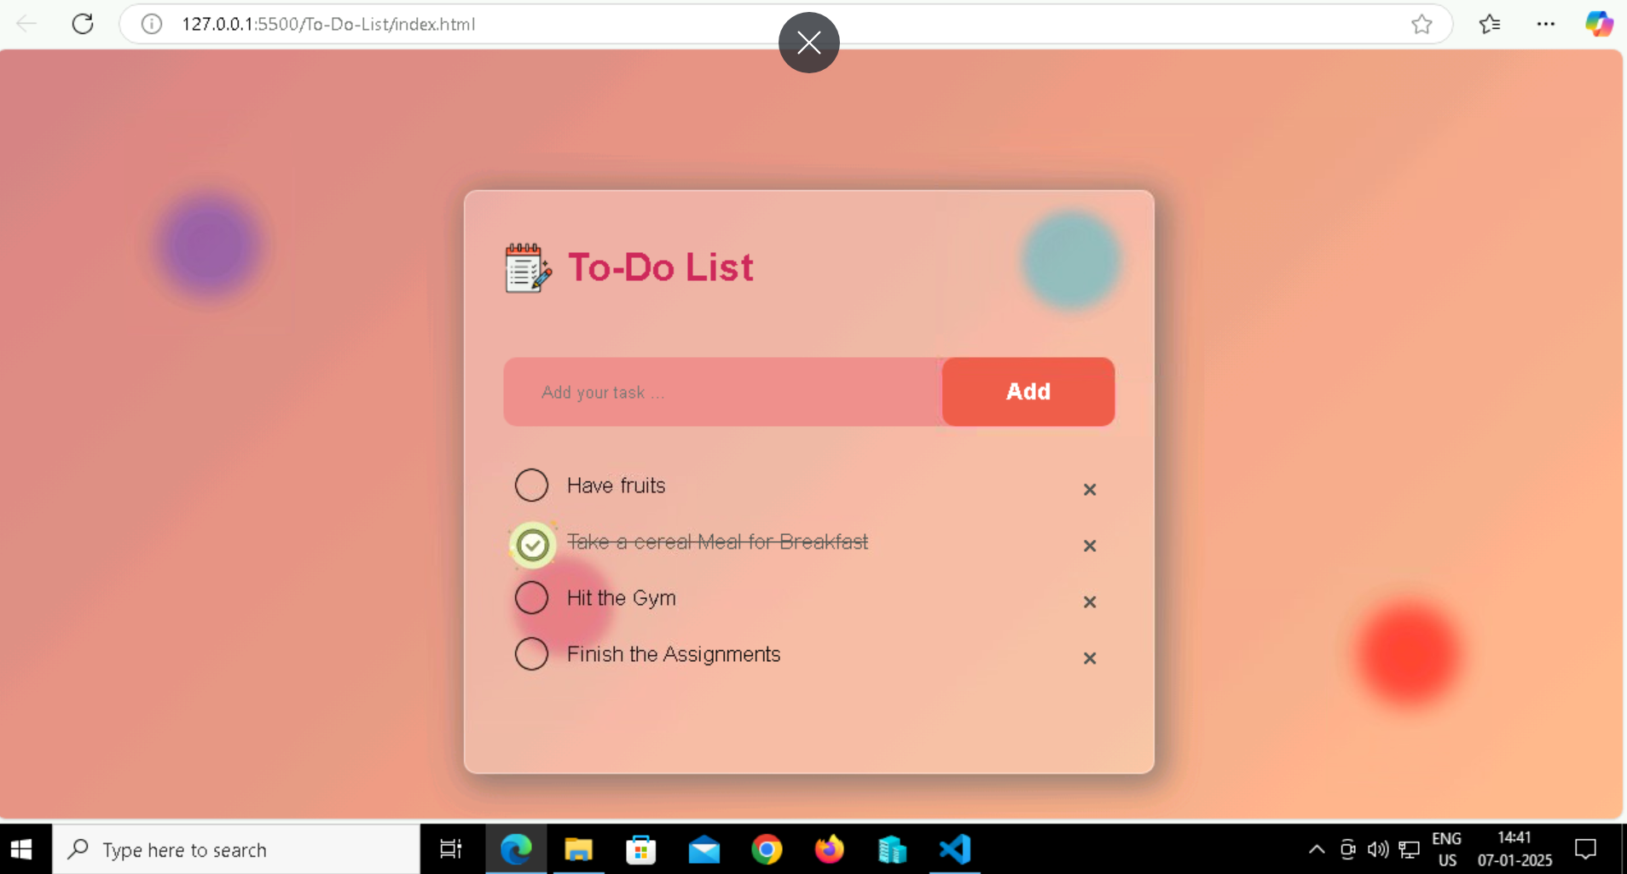

**================================END=======================================**